|  |
| --- |
|  |
| The Queen’s Story |
| Team 404 |

|  |
| --- |
| Rudy Caliph, Randy Peacock, Craig Rose, Stephen Dos Santos, Richard Andrews  4/8/2014 |

Contents

Purpose of the project 4

Scope of the project 4

Overview of the document 5

Gantt Charts 5

Most recent (final, when complete) 5

Requirements Specification (Analysis) 6

Functional requirements (Use Case diagram) 6

Non-functional requirements 7

Software Design (Use Software Design and Final Design documents) 8

Software model and tools 8

Final Design documents 8

**The Queen’s Story** 8

**Design History** 9

**Version 1.00** 9

**Version 1.01** 9

**Game Overview** 10

**Philosophy** 10

**Philosophical point #1** 10

**Philosophical point #2** 10

**Philosophical point #3** 10

**Common Questions** 10

**What is the game?** 10

**Why create this game?** 10

**Where does the game take place?** 10

**What do I control?** 10

**How many characters do I control?** 10

**What is the main focus?** 10

**What’s different?** 10

**Feature Set** 11

**General Features** 11

**Gameplay** 11

**The Game World** 12

**Overview** 12

**World Area #1** 12

**World Area #2** 12

**The Physical World** 12

**Overview** 12

**Key Locations** 12

**Travel** 12

**Scale** 12

**Objects** 12

**Weather** 12

**Time** 12

**Rendering System** 13

**Overview** 13

**2D/3D Rendering** 13

**Camera** 13

**Overview** 13

**Game Engine** 13

**Overview** 13

**Game Engine Detail #1** 13

**Collision Detection** 13

**Game Characters** 14

**Overview** 14

**Enemies and Monsters** 14

**User Interface** 15

**Overview** 15

**User Interface Detail #1** 15

**User Interface Detail #2** 15

**Weapons** 16

**Overview** 16

**Weapons Details #1** 16

**Weapons Details #2** 16

**Musical Scores and Sound Effects** 17

**Overview** 17

**Sound effects** 17

**Background Music** 17

**Single-Player Game** 18

**Overview** 18

**Single Player Game Detail #1** 18

**Single Player Game Detail #2** 18

**Story** 18

**Hours of Gameplay** 18

**Victory Conditions** 18

UI Design 19

Implementation 20

Source Code 20

Github Link 20

Testing 21

Test plan 21

**Goals** 21

**Assumptions** 21

**Risks and Assets** 21

**3.1 Test Objectives** 21

**3.2 Types of Testing** 21

**3.2.1 Unit testing** 21

**3.2.2 Integration testing** 22

**3.2.3 Play Testing** 22

**3.2.4 Focus Testing** 22

Test Reports 23

UI Test Report 23

Playtest Report 24

User Manual 25

Conclusions and Recommendations 25

# Purpose of the project

The purpose it to create an old side scrolling game with a modern take with the Unity3D.

# Scope of the project

The scope of the project will be encompassing in five parts:

* The Prototype Forest Level
* Player with actions and movement
* Enemies with A.I
* All collisions and hit detection
* U.I

# Overview of the document

## Gantt Charts

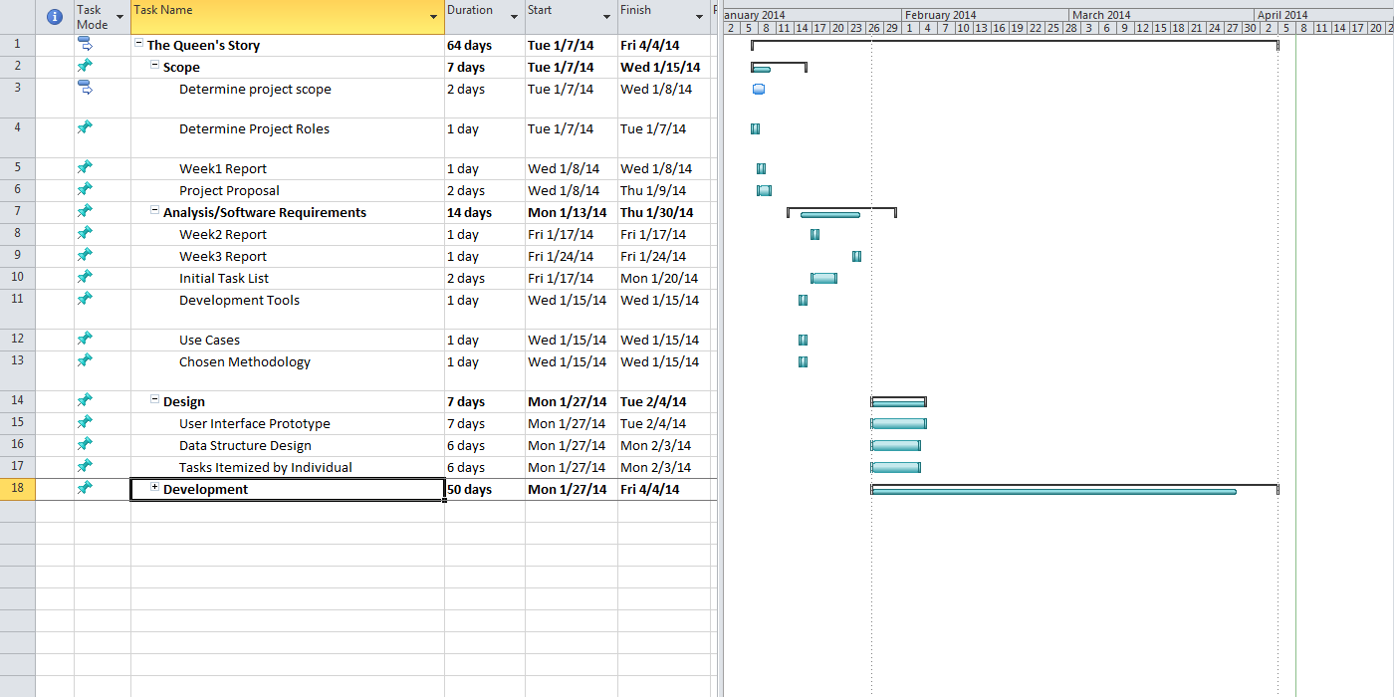

## Most recent (final, when complete)

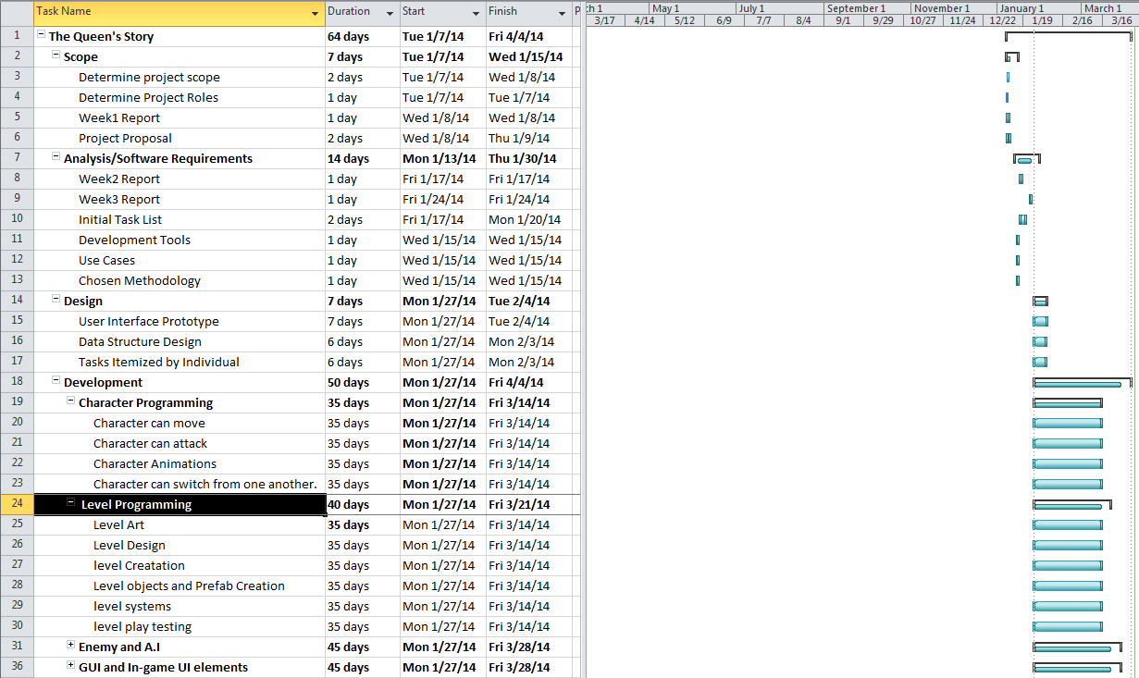

# Requirements Specification (Analysis)

## Functional requirements (Use Case diagram)

|  |
| --- |
|  |
| **Character Programming** |
| Character can move |
| Character can attack |
| Character Animations |
| Character can switch from one another. |
| **Level Programming** |
| Level Art |
| Level Design |
| level Creation |
| Level objects and Prefab Creation |
| level systems |
| level play testing |
| **Enemy and A.I** |
| Enemy can move |
| Enemy can attack player |
| Enemy Animations |
| Enemy has individual A.I |

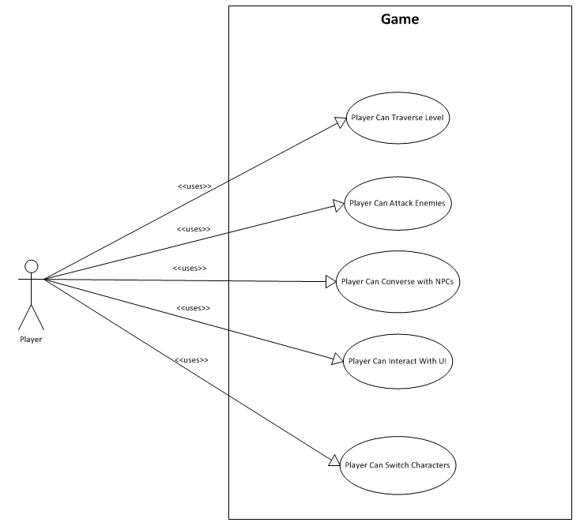

## Non-functional requirements

|  |
| --- |
| Task Name |
| **GUI and In-game UI elements** |
| In-game GUI |
| Game instructions |
| Game Menu GUI |

# Software Design (Use Software Design and Final Design documents)

## Software model and tools

* Game
* Programmed in Unity3d
* Github for source code

## Final Design documents

**Design Document for:**

**The Queen’s Story**

All work Copyright ©2014 by Rudy Caliph

Written by Rudy Caliph

Version # 1.01

Tuesday, April 08, 2014

**Design History**

Here will contain the history of the game design and the changes and updates.

**Version 1.00**

Version 1.00 initial

1. Draft in progress.

**Version 1.01**

Version 1.00 initial

1. Completed
2. Improvements made and refined.

**Game Overview**

**Philosophy**

**Philosophical point #1**

A Game made in unity to be ported to multiple platforms.

**Philosophical point #2**

Great Gameplay that is simple yet complex.

**Philosophical point #3**

Unique systems that reflect through the entire game.

**Common Questions**

**What is the game?**

The game is a side scrolling game that allows you to play as two characters that you can switch from during gameplay. With the systems like skills and the combo systems allow the play to feel more engaged with the game and blend into the story.

**Why create this game?**

This is from my passion of videogames with the perfect blend of gameplay and story, the type that lets you forget that there is a controller in your hand and lets you be engulfed in the game world and doesn’t let go till the end.

**Where does the game take place?**

The game is in the world of “Indra” a high fantasy world of kingdoms and magic. One where tribes of people have an almost genetic ties with a type of elemental magic.

**What do I control?**

In the Queen’s Story you control Kissandra (Red) and Zale (Blue).

**How many characters do I control?**

2.

**What is the main focus?**

The main focus of Kissandra and Zale’s journey is to confront the king of the northern kingdom to solve the mysteries of their past’s and decide their future’s whatever happen they will do it together.

**What’s different?**

With the over saturation of shooter and mobile games with very little story based games I would like to make a game that brings these element into a game that I would want to play as there is very little in the current market.

**Feature Set**

**General Features**

2D world

HD visuals

Dual Character Gameplay System

Engaging story

**Gameplay**

Elemental puzzles

Fire and Ice combat system

Combo system

Real-time character switching

**The Game World**

**Overview**

The world of Indra is one with few large groups of people and more small villages with only four great kingdoms set in a more high fantasy medieval time period.

**World Area #1**

Most of the opening levels of the game will concentrate on the forest area’s with some outlook outposts of the north kingdom.

**World Area #2**

The second area in the game will be a military type town with a large school academy in the middle.

**The Physical World**

**Overview**

The area of Indra we will focus on is the western continent from the middle upwards to the north.

**Key Locations**

* **Forest Gale** – the initial level in the game and where the two main characters meet.
* **Northern Kingdom Military Academy** – a military type town where the forces of the north train their people for combat and using their magic.
* **The Border** – This area will be a level were Kissandra and Zale try to cross the border to the Northern kingdom.
* **Rebel Base** – A later hub for learning new skills among other things.
* **The Capital** – This area will be near the end were the rebels attack the kingdom.
* **The Throne Room** – inside the castle this is where the final battle will take place.

**Travel**

Players will be walking throughout the game as represented as levels but will have fast travel later in the game.

**Scale**

Everything will be in a side scrolling nature with levels being interconnected and able to fast travel between.

**Objects**

Certain barriers will only be unlocked when you learn a skill or are on a side quest.

**Weather**

The only weather other than sunny will be winter weather in the northern kingdom.

**Time**

Time will only progress through the story or side quests will be dated.

**Rendering System**

**Overview**

We will be using the unity2D system for rendering are game.

**2D/3D Rendering**

Since it’s a 2D game we will be using 2D sprites and textures.

**Camera**

**Overview**

A normal 2D camera that will follow the player as they move left to right in game.

**Game Engine**

**Overview**

The game will be running on the Unty3D engine.

**Game Engine Detail #1**

The game engine will help us in the future to port the game easily to other platforms.

**Collision Detection**

The new 2D functions of Unity 4.2 allows us better control of the collision with its 2D rigged bodies and box colliders.

**Game Characters**

**Overview**

The story will focus on two characters Kissandra (Red) and Zale (blue).

**Red:** A 19-year old mercenary. 10 years after the king of Northern Kingdom attacked her village “Alma” and killed her parents she left her friends and brother to see the world instead of going into hiding. She now tries to forget the past and move on till she meets someone who reopens old wounds. Notable physical features are her red hair and eyes.

**Blue:** An 18 year old Prince. One who recently witnesses his father the king of Northern Kingdom kill his mother the Queen. He steals the kings journal and documents which leads him to believe that his sister’s life in next. He runs away in the dead of night to seek the old friends of his mother, the people of Alma not having any knowledge of what his father did in the past. Notable physical features are his blue hair and eyes.

**Enemies and Monsters**

* **Wildlife -**  wolfs and other creatures will appear at the start.
* **Thieves & Hunters –** these common enemies will appear throughout the game.
* **Northern Kingdom forces –** This will appear as knights or spell fencers.

**User Interface**

**Overview**

The game’s UI will be very minimalistic, the only UI elements in game will be the player stats like HP, MP Etc. and the combo meter.

**User Interface Detail #1**

* The combo meter will keep track of hit you make on the enemies.

**User Interface Detail #2**

* HP or health points will keep track of the player’s health.

**Weapons**

**Overview**

The combat in the game will be red with a sword and blue with a shield and ice projectiles.

**Weapons Details #1**

* The Sword will have fire properties that will be useful against certain enemies and environmental barriers.

**Weapons Details #2**

* The ice projectiles will be useful against heavy melee.

**Musical Scores and Sound Effects**

**Overview**

The music and sound in the game would mostly be commissioned but in the early stages we will use are own sounds and music along with other placeholder pieces.

**Sound effects**

The sounds will be used mostly in player and enemies’ movement and actions.

**Background Music**

We will be mostly using single tracks that will loop during the stages.

**Single-Player Game**

**Overview**

The game will be a more traditional 2D platformer with more modern improvements.

**Single Player Game Detail #1**

* Players will start with basic platforming controls but will change as the player progress adding in powers like air dashing and double jumping.

**Single Player Game Detail #2**

* The game will feature a Dual-Character system in which the player will have control of the two main characters using the shoulder buttons to switch actions with each.

**Story**

The story will revolve around the two main characters and their journey to confront the northern king.

**Hours of Gameplay**

Around 8-10 hours of gameplay I don’t want to have a game that over stays its welcome and the player becomes board with any aspect be it like something like a side quest.

**Victory Conditions**

It will be a more linear story type games were you progress on a set path from start to end.

## UI Design

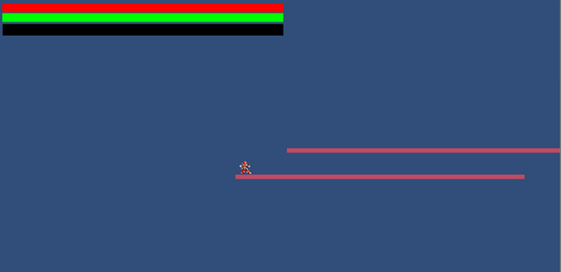

# Implementation

## Source Code

### Github Link

<https://github.com/rudycaliph/The_Queens_Story/>

# Testing

## Test plan

1. **Introduction**

**Goals**

The project the queen’s story will be a 2D game and will tested in an iterative process.

**Assumptions**

*Any assumptions which may affect the understanding or execution of this plan should be recorded here.*

**Risks and Assets**

When discussing new features or implementations we talk as a group to determine the best course of action.

1. **Scope**

**2.1 Features to be tested**

* A.I
* Combat
* Enemy creations
* Animations
* Collisions
* Hit detection

**2.2 Features not to be tested**

* Sprite renderer
* Image Assets
* Music Assets

1. **Testing Procedures**

Each developer will be expected to do their own individual testing and reports.

**3.1 Test Objectives**

We will use testing to ensure that all components of the game will be in working order and bug free.

**3.2 Types of Testing**

*Describe the types of testing that the project will use.*

**3.2.1 Unit testing**

Certain components of work we will be conducting unit testing.

**3.2.2 Integration testing**

The integration testing will be conducted by Randy Peacock and will be done will creating each new build of the game.

**3.2.3 Play Testing**

We will be conducting play testing where we will test the game and its systems for bugs after each build.

**3.2.4 Focus Testing**

We will have our friends and family play the game and get feedback for future improvements.

1. **Schedule and Deliverables**

|  |  |
| --- | --- |
| **Schedule** | **deliverables** |
| Week 11 | Play/Focus Testing |
| Week 12 | Unit testing |
| Week 13 | Integration testing |

## Test Reports

### UI Test Report

**Summary**

Testing the user interface bar to make sure they are able to properly work.

* Health – Tracks the player’s life.
* Stamina – Tracks the player’s stamina
* Special – Tracks the player’s special meter.

**Variances**

* Using unity’s inspector to alter the UI to test if they are tracking properly.
  + curStamina, maxStamina
  + curHealth, maxHealth
  + curSpecial, maxSpecial

**Comprehensiveness Assessment**

The process was effective in testing the required needs, and showed many different weaknesses in the interface that might have been a problem if unattended to for the final product such as improper tracking.

**Summary of Results**

User Interface tracks the desired variables correctly going from the max point, to the lowest point while only having a few problems. After receiving help from the teacher, all problems were fixed.

**Evaluation**

The quality of the software is moderate, as it is not up to the best level that might be attainable; however it is for the current needs and does not need any revamp, as it works properly.

* Limitations of this software are that it is rather bland.
* Failure likelihood is non-existent as it is rather straightforward.

**Summary of Activities**

Two hours were spent testing the tracking abilities of the UI, instead of the one hour that was believed it should have taken.

### Playtest Report

**Summary**

Pre Alpha version

•  **Level** – The Pre Alpha version of the game will be shown and play by five individuals who asked to remain anonymous for testing.

•  **Player movement/actions** – The participants will give feedback on the feel of the players in the game.

**Variances**

The play test will help us examine the level and the placement of objects along with the player’s movements and actions.

•  Change requests

•  Enhancement requests

•  Game breaking Bug

**Feedback Assessment**

After playing the game we ask the player about how the game felt with the character movements, actions and about the level.

•  character actions

•  level bugs

•  other game bugs

**Summary of Results**

Among the people that tested the game we found that there were common trends for certain areas of the level and some bugs when performing certain actions as the character such as:

•  Trap Areas

•  Character duplications

•  objects without collision

•  unreachable areas

**Summary of Activities**

•  Play time

•  feedback

**Approvals**

Applicants were anonymous.

## User Manual

# Conclusions and Recommendations